User Manual - Sydney Airbnb Data Analysis Tool

**Step 2: Run the Program by using the Run button found in any IDE.**

**Step 1: Open the Program using any IDE by Launching HomePage.py**

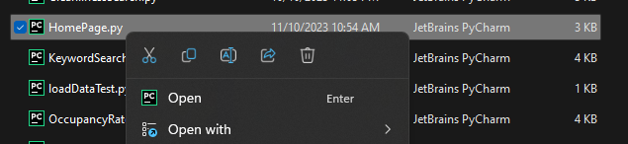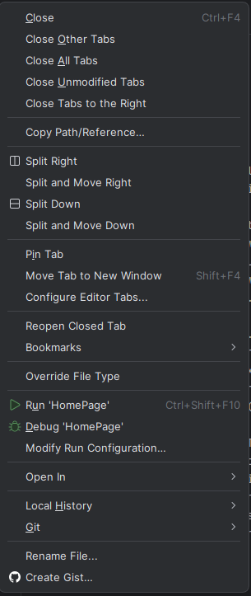

**You should be able to see the Homepage of the Data Tool.**

**4**

**3**

**5**

**2**

**1**

**2**

**Step 5: Enter the Specified Suburb you would like to search for and Upload the ‘Listings’ CSV file. Enter the specified date and period and hit Search to see the Listings specified for the suburb.**

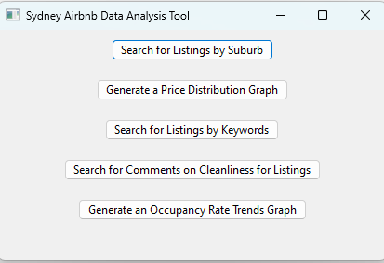

**Step 4: Click the ‘Search for Listings by Suburb’ to search for listings within a specified suburb.**

**You should be able to see the listings in a table that contains each listings between the specified time period for that specified suburb. If you cannot see the table, make sure you upload the ‘Listings’ CSV file and the specified period is before 2019.**

**Step 7: Click on the ‘Generate a Price Distribution Graph’ button to go the Price Distribution feature.**

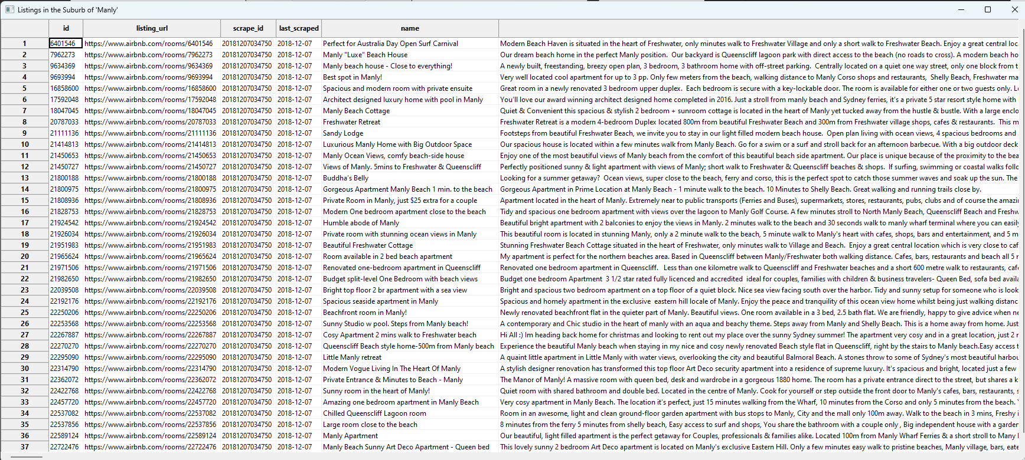

**Step 6: Close the Table and ‘Suburb Search’ feature to go back to the homepage.**



**31**

**2**

**1**

**Step 9: Close both pop-up dialogs to go back to the Homepage.**

**You should be able to see the graph. If you cannot, make sure the specified period is before 2019 and the ‘Listings’ CSV file is uploaded.**

**Step 8: Input the Start and End Data and Upload the ‘Listings’ CSV file. Click the ‘Generate Price Distribution Graph’ to generate the graph.**

**Step 10: Click on the ‘Search for Listings by Keywords’ button.**

**Step 11: Input the keyword you would like to search for in the search bar and then input the start and end period into the data picker. Upload the ‘Listings’ file using the upload CSV file button and then hit the ‘Search’ button.**

**1**

**2**

**33**

**4e**

**You should be able to see the generated graph for the Price Distribution over time for listings in the specified time period. If you cannot see the graph, make sure the ‘Listings’ CSV file is uploaded and the specified time period is before 2019.**

**3**

**44**

**1**

**2**

**5**

**Step 14: Now input the word you would like to search for regarding on factors on cleanliness, the inputted word must be on the list of allowed words, Upload the CSV file using the ‘Upload CSV file’ button and upload the ‘Reviews’ CSV file and hit the ‘Search’ button.**

**Step 13: Now click on the ‘Search for Comments on Cleanliness for Listings’ button to access the Cleanliness Comments feature.**

**Step 12: Close both pop-up dialogs to go back to the homepage.**

**You should be able to see the graph that shows the frequency of the word that the user would like to search for in the comments of the reviews related to cleanliness. If the graph is not showing make sure the ‘Reviews’ CSV file is uploaded and the word is in the list of allowed words.**

**Step 15: Close both dialogs to get back to the Homepage.**

**Step 16: Select the ‘Generate an Occupancy Rate Trends Graph’ feature to go to the Occupancy Rate feature.**

**You should be able to see the Occupancy Rate Trends Graph for Different Suburbs in the specified time period. If you cannot see the graph, make sure you have uploaded the ‘Listings’ CSV file and that the specified period is before 2019.**

**Step 17: Upload the ‘Listings’ CSV file by clicking on the upload CSV file button and choose the specified period you would like to generate the graph for and click the ‘Generate Occupancy Rate Trends’ button to generate the graph.**

**END OF MANUAL.**

**3**

**2**

**1**